Owen Sound Cross Country Ski Club
Box 1033
Owen Sound • Ontario • N4K 6V6
www.massiehills.com
AGM April 20,2023 Minutes
Harmony Centre, Owen Sound

- Motion to carry the minutes from the last AGM. Gary motions to pass, Brent seconds, all in favour. Passed

- Presidents Report
Kelly Rogers- Late start to the year, tough navigating the freeze/thaw of the winter. Membership was down from previous years but overall an increase since the pandemic. New additions: picnic table, new groomer this season.

- Call for Election of the Officers and Executive for 2023-2024
Kelly calls for a motion to pass the request for the following people to fill the following positions:
Kelly Rogers – President
Don Eby – Vice President
Aimee Vereecke – Secretary/Registrar
Unfilled – Treasurer
Carl Sadler – Trail Manager
Gary Shute – Assistant Trail Manager
Jim Pappas – Member at Large
Brian Goodings – Member at Large
Doug Stewart and Bill Oliver - not present, but will stand for the board and decide who will fill the treasurer’s position at a later date

Note for next year: Make a call beforehand for any interested members in being part of the executive.
Carl motions to pass the outlined positions and members that will serve as 2023-24 OSCCSC Executive. Jim seconds, all in favour, passed.

- Treasurer’s Report
Brent Radbourne

See Financial statements for fiscal year September 2, 2021 to August 31, 2022
Andrew Howlett reviewed our 21/22 fiscal year and made suggestions (see attached)
Suggestions included:
- Annual life time membership awarded to Chris Hughes, review how this is allocated
- Procedure in previous years, paying groomers for expenses/costs (gas/maintenance) Receipts did not all match up with these costs. Income often came in at the end of the year, that money was then carried on to help pay for the next start up year. Suggestion was made to fine tune this process to ensure there is a start/finish to the season.
- $12,000 transfer into our account, came from an old account into our new BMO account
- $34.79 missing cost, receipt was accounted for but may have been missed in the review
- How do you address the day fees and the envelopes that act as a waiver. Looking at ways to modernize how our members pay for day fees. Add a digital version perhaps (QR Code/zone 4 link)
- Don motions to investigate digital options for paying day fees with a waiver included, seconded by Aimee, passed.
Review May 1 2022-April 23 2023
- See attached
Kelly suggests reviewing the 2022-23 and 23-24 together. Approach Andrew Howlett to do this, prior to the start of the new Treasurers position commencing.
Brent motions to pass the budget report, seconded by Carl, all say yes, passed.
Kelly motions to provide an honorarium to the person who conducts the annual review.
Carl seconds, all agree, passed.
Kelly motions, Neil seconds to appoint Andrew Howlett as the reviewer of the 2022-23 and 2023-24 ski season. All agree, passed.

Membership/Secretary Report
Aimee Vereecke
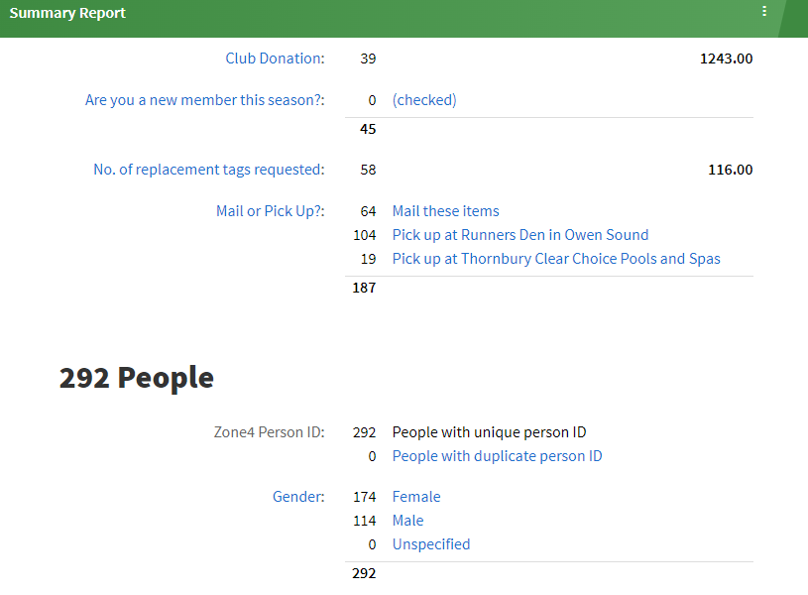

2022 Memberships :323 members, $1400 in donations, 50% pick up last year, 67 % pick up this year, savings of $131.61 cents

Suggestion was made to investigate an exit report for those that did not renew their memberships.

Trail & Grooming Report
Carl Sadler/Gary Shute
The new groomer proved to be a great resource for great trails. With large amounts of snow, it makes the best sense to pack the snow first with a snow machine and then use the new groomer to set tracks. Very important to pack first. Many hours of work put into maintaining these trails. New groomer has been assessed and tuned up. Significant reduction of fuel use with the new machine. The old machine was sold to a community member to purchase for parts. Payments will be made in two installments. Looking to assess the trails on the Blue trail this summer to remove any trees that are impeding the grooming process and to improve drainage. Yellow trail was discussed as needing some work to improve drainage.
Parking Lot Report
Kelly Rogers
Parking has been an issue at both entrances over the past 3 years. The board has been making plans to create a parking lot at the main entrance. Two quotes were sought. The first quote was approx. 48,000.00 .The second quote was much more affordable approx. 12,000.00.
Bruce Trail has money to support this development, Grey Sauble Conservation and Grey County are all in support of a new parking lot. On May 9, Kelly will be meeting with Grey County and Grey Sauble Conservation to determine financing. GSCA is looking after NEC permit. We will need to also think about who will pay for the plowing of the lot during the season. We need to inquire about what is required with regards to insurance.
Don motions, Carl seconds, that we seriously investigate and continue our discussions with our partners and spend up to 10,000.00 to support the development of a new parking lot. All in favour, passed.
Comments from Floor
Very positive feedback regarding the emails sent to members outlining the conditions of the trails.
Suggestions to organize a meet up to organize skiers to ski together
Acknowledge Kelly’s contributions to the club, she is a great leader and we are thankful for her time and energy.
Motion to adjourn, Kelly, Brent seconds, all approve.

