OSCCSC AGM
October 19, 2022

- Presidents Report: Kelly Rogers
Second pandemic winter, continued increase in membership. We had some great skiing into March this past year. Thanks to our volunteers for all the work grooming. We had been considering applying for a Grey/Bruce Foundation grant. The timelines did not work with the life expectancy of our snow machine/groomer. We had putting aside some money to purchase a machine, which we were able to do with the increased pandemic income. We purchased a Yamaha Grizzly ATV with tracks for grooming this year. We also purchased a picnic table for the top of the pink loop. This area will be groomed so that skiers can enjoy a rest and a snack.
Thomas Hakala and Vic Michener, thanks to both of you for your behind the scenes work you do with graphic design and website maintenance.

- Approval of the minutes of the June 23, 2021 Annual General Meeting
Kelly motioned to approve the minutes from the 2021 AGM. Jim seconded and all approved.
- Approval of New Bylaws – Don Eby
Don Eby reviewed the new regulations that not-for-profit groups must adhere to. Don worked over this past year to write new club bylaws and adhere to these new expectations. The Board has reviewed these, made amendments, and passed them. These were posted for the membership to review. There were no questions from the membership.
Don motions to accept the bylaws. Carl seconds the motion. No objections. Passed
Don motions to authorize the treasurer/president to have the discretion to spend $1000.00 per purchase without the permission from the Board. A report would be provided at the next Board meeting. Seconded by Brian, all in favour. Passed.

- Proposed Officers and Executive for 2022-2023
Kelly Rogers – President Don Eby – Vice President Aimee Vereecke – Secretary/Registrar Brent Radbourne – Treasurer Carl Sadler – Trail Manager Gary Shute – Assistant Trail Manager Jim Pappas – Member at Large Brian Goodings – Member at Large
No challenges noted. Kelly motions to pass the members of the executive for the 2022-23 season. All accepted, passed.

- Financial Report – Brent Radbourne
Good year, but shows loss because of Capital purchase: Yamaha ATV $20,606.66
Current Balance as of Oct 2022: 16,997,98 in our account
Question from Ted Z. Does the cub pay and conservation fees: Yes, we pay $113.00 annual fee (includes HST).
Year End: Would like to change to April 30th, this requires some changes with Canada Revenue, a request has been made to Canada Revenue Agency. CRA requests more information to justify the change. Brent will follow up.
Brent suggests that we enlist a 3rd party source to review our books on an annual basis. Andrew Howlett, Bruce Ski Club Treasurer, has indicated he would review our financial accounts on a yearly basis. No objections.
6. Membership Report 2021/22– Aimee Vereecke
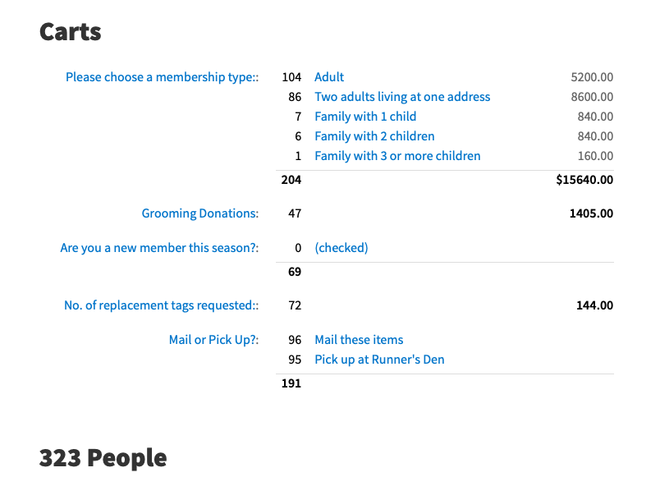
New sticker/tag pick up for 2022/23: Clear Choice Pools and Spas in Thornbury will hand out our tags/stickers at this location.
Fees were increased for adults by $10.00. This fee increase will cover the Zone 4 costs that are due at the end of the online checkout process and also the $2.00 increase in the XCSO insurance fee. The cost for children was not increased.

7. Discussion and Approval of Mission Statement: To provide classical cross country ski trails in a natural setting for the enjoyment of the community.
A motion was made to alter the word “classical” to classic. The following mission statement was motioned:
To provide classic cross-country ski trails in a natural environment for the enjoyment of the community.
All in favour.
8. Parking Update
Parking Lot Discussion: The Board investigated options to enlarge our parking lot. Initial costs were over $50,000.00. Efforts to share costs with Bruce Trail and Grey County. Board agrees we should continue to move forward with ta parking lot for safety reasons. Other options will be explored.
Brian discussed the issue of plowing, insurance is required and costs are such that this is a huge hinderance as these costs are significant.
Short term solutions to parking issue: Ani suggests improving the signage, and to change the speed in the area.
Brian suggests we could approach the Meaford township to make adjustment to the speed or increase signage to help prevent any accidents. Carl and Gary have connections with the municipality and will look after this.
Tom H. has done work with the Tom Thomson trail. They are working with the municipality to ensure parking is safe. Good resource.

9. Trail & Grooming Report: Carl Sadler, Gary Shute
We are waiting for permission to get on the trails once logging is completed. Trail clearing day is to be announced.

10. Adjournment
Kelly motions to adjourn the meeting at 8:10. Seconded by Carl.
Meeting adjourned.

